**四川省2019年普通高校职教师资班和高职班对口招生统一考试**

**英语**

第Ⅰ卷（共两部分 满分70分）

注意事项:

1. 必须使用2B铅笔在答题卡上将所选答案对应的标号涂黑。

2. 第Ⅰ卷共两部分,满分70分。

第一部分 英语知识运用（共两节；满分30分）

第一节 单项选择（共15小题；每小题1分，满分15分）

从A、B、C、D四个选项中，选出可以填入空白处的最佳选项，并在答题卡上将该项涂黑。

1. — ______ ？

—I work in a hospital.

A. How do you do B. What do you do

C. How is everything D. What would you like

【答案】B

【详解】句意：--______

--我在医院工作。

考查情景交际。回答是我在医院工作，也就是对职业进行了回答，那么文具就要针对职业进行提问。A. How do you do你好 B. What do you do 你是做什么的？C. How is everything 一切都好吗？D. What would you like你想要什么？ 故选B.

2. ______ apple ______ day keeps the doctor away.

A. A; a B. A; an C. An; an D. An; a

【答案】D

【详解】句意：一天一苹果医生远离我。

考查冠词用法。Apple前用an, day 前用a 表示“一”。

3. A national park ______ here in 1952.

A. was created B. has created

C. created D. is created

【答案】A

【详解】句意：国家公园于1952年创建。

考查被动语态。公园是被创立的，用被动语态。时间是1952年，过去的时间，用过去时。故选A.

4. ______ funny the story is!

A. Why B. What C. Which D. How

【答案】D

【详解】句意：多么有趣的故事啊！

考查感叹句。感叹句一般由what/how引导。what 引导的感叹句句型为“what+. a/an+形容词+可数名词单数+主语+谓语!”和“what+形容词十可数名词复数/不可数名词十主语十谓语!”;how引导的感叹句句型为“how+形容词/副词十主语十谓语!”。中心词funny为形容词,前面用how。故选D。

5. She was trying to solve the problem all by ______ .

A. her B. herself C. hers D. she

【答案】B

【详解】句意：她试图通过______来解决这个问题。

考查by oneself 独自，主语是she, 所以横线处用反身代词herself.

6. Jane said that she didn’t remember ______ else.

A. anything B. everything C. nothing D. something

【答案】A

【详解】句意：Jane说她记不住其他任何事情。

考查不定代词。anything 意为“任何事/物”;everything意为“每件事/物”;nothing意为“没有任何事/物”; something意为“某事，某物”。根据语境可知应选anything,anything一般用于否定句中。故选A。

7. I asked her ______ she was talking to.

A. why B. where C. that D. who

【答案】D

【详解】句意：我问她______她在和她说话

考查宾语从句。分析句子结构，空格部分充当talking to的宾语，此处用who作宾语从句的引导词。故选D。

8. The roof of the house is made ______ glass.

A. in B. from C. of D. by

【答案】C

【详解】句意：这个房子的屋顶是由玻璃制成的。

考查be made of 由……制成。故选C.

9. You’ve talked to her, ______ you?

A. don’t B. aren’t C. haven’t D. won’t

【答案】C

【详解】句意：你和她谈过了，是吗？

考查反义疑问句。反意疑问句是由陈述句和附在其后的附加疑问句组成。其中附加疑问句是对陈述句所说的事实或观点提出疑问，起证实作用，一般用于证实说话者所说的事实或观点。(表示说话者对某事有一定看法，但又不完全确定，需要对方加以证实。)翻译为“是吗”have用在完成时中，反义疑问句谓语动词用have

They have known the matter, haven’t they? 故选C.

10. I will give a party ______ I pass the exam.

A. if B. whether C. though D. while

【答案】A

【详解】句意：我将举办一个聚会______我通过了考试。

考查连词辨析，引导状语从句，if“如果”，whether“是否”，thought“尽管”，while“当……时候”故选A.

11. Lily enjoys ______ chess, but she doesn’t like football games.

A. played B. playing C. play D. to play

【答案】B

【详解】句意：莉莉喜欢下棋，但她不喜欢足球比赛。

考查enjoy doing. Sth. 喜欢做……。

12. The story tells about a small town ______ Tom grew up.

A. which B. when C. where D. that

【答案】C

【详解】句意：这个故事讲的是汤姆长大的一个小镇。

考查定语从句。先行词town在定语从句中作地点状语，用关系副词where引导。

13. Hurry up! Our train ______ in ten minutes.

A. is left B. is leaving C. has left D. left

【答案】B

【详解】句意：快点我们的火车十分钟后______。

考查一般将来时。题干中的in ten minutes表示“在十分钟之后”，表示按计划，安排即将发生的东顾总，用现在时表示将来，故选B.

14. It was in Xinhua Vocational School ______ Li Xiaonian first met Mr. Smith.

A. that B. why C. which D. where

【答案】A

【详解】句意：李小年第一次见到史密斯是在新华职业学校。

考查强调句型。1. [陈述句](https://baike.baidu.com/item/%E9%99%88%E8%BF%B0%E5%8F%A5?fromModule=lemma_inlink" \t "https://baike.baidu.com/item/%E5%BC%BA%E8%B0%83%E5%8F%A5/_blank)的[强调](https://baike.baidu.com/item/%E5%BC%BA%E8%B0%83?fromModule=lemma_inlink" \t "https://baike.baidu.com/item/%E5%BC%BA%E8%B0%83%E5%8F%A5/_blank)[句型](https://baike.baidu.com/item/%E5%8F%A5%E5%9E%8B?fromModule=lemma_inlink" \t "https://baike.baidu.com/item/%E5%BC%BA%E8%B0%83%E5%8F%A5/_blank)It is/ was + 被强调部分（通常是[主语](https://baike.baidu.com/item/%E4%B8%BB%E8%AF%AD?fromModule=lemma_inlink" \t "https://baike.baidu.com/item/%E5%BC%BA%E8%B0%83%E5%8F%A5/_blank)、[宾语](https://baike.baidu.com/item/%E5%AE%BE%E8%AF%AD?fromModule=lemma_inlink" \t "https://baike.baidu.com/item/%E5%BC%BA%E8%B0%83%E5%8F%A5/_blank)或[状语](https://baike.baidu.com/item/%E7%8A%B6%E8%AF%AD?fromModule=lemma_inlink" \t "https://baike.baidu.com/item/%E5%BC%BA%E8%B0%83%E5%8F%A5/_blank)）+ that/ who（当强调主语且主语指人）+ 其他部分。例子 It was yesterday that he met Li Ping.

15. People often think they are ______ than they really are.

A. even attractive B. much attractive

C. most attractive D. more attractive

【答案】D

【详解】句意：人们通常认为自己比实际上更具吸引力。

考查比较级。关键词than,所以应该填写比较级。attractive多音节词，所以选D.

第二节 语言应用（共10小题；每小题1.5分，满分15分）

**Part A** 根据下列图片所提供的信息，从16～22题所给的三个选项（A、B、C）中，选出最佳选项，并在答题卡上将该项涂黑。

16. The gallery opens at ______ on Sundays.

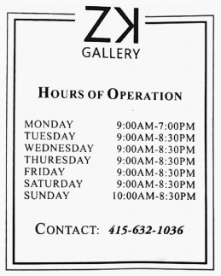

1. 8:30 AM. B. 9:00 AM. C. 10:00 AM.

【答案】C

【详解】句意：画廊星期日在______开门。根据SUNDAY 10AM-8:30PM, 选C.

17. According to the receipt, how much was paid?

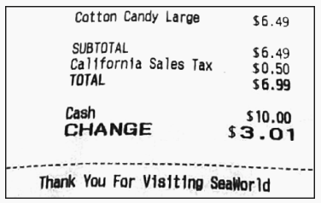

1. $3.01 B. $6.49 C. $6.99.

【答案】C

【详解】根据小票TOTAL $6.99, 故选C.

18. To go to the pool, you should ______ .

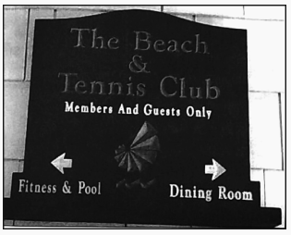

1. turn left B. turn right C. go forward

【答案】A

【详解】根据题干始中的pool在图片上找到对应信息Fitness&Pool,其前面由个方向向左的箭头，故选A。

19. This is probably a(n) ______ .

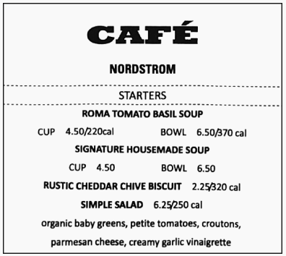

1. newspaper B. advertisement C. menu

【答案】C

【详解】句意：根据图片上的soup,biscuit, tomatoes等表示食物的单词及价格，可知这是餐馆的菜单。故选C.

20. According to the sign, parking 2 hours costs ______ .

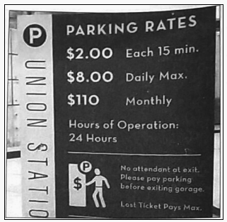

1. $4 B. $8 C. $16

【答案】B

【详解】句意：根据&2.00 each 15 min.和$8.00 daily Max. 可知停车两小时需要$8. 故选B.

21. According to the card. the restaurant is in ________.

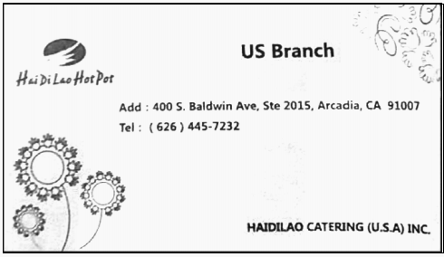

1. America B. China C. Japan

【答案】A

【详解】根据卡片上USA可知，餐馆在美国。故选A。

22. Which of the following is allowed on ART?

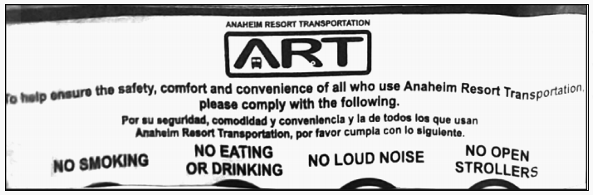

1. Smoking. B. Eating. C. Reading.

【答案】C

【详解】根据no smoking , no eating or drinking, no loud noise, no open strollers可知，答案选C。

**Part B** 根据下图所提供的信息，从23～25题所给的三个选项（A、B、C）中，选出最佳选项，并在答题卡上将该项涂黑。

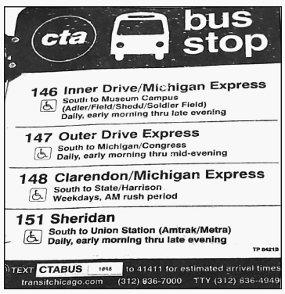

23. Which bus to take if you want to visit Congress?

A. 146. B. 147. C. 148.

【答案】B

【详解】根据147 outer drive express, 答案选B。

24. Which bus doesn’t run on weekends?

A. 147. B. 148. C. 151.

【答案】B

【详解】148 的时间是weekdays ，工作日，所以选B.

25. To get the arrival time of a bus, you can _______.

A. text to 41411 B. check the sign C. call(312)836-4994

【答案】A

【详解】表格下方text ctabus to 41411, 故选A.

第二部分 阅读理解（5篇短文，共20小题；每小题2分，满分40分）

阅读下列短文，从每题所给的四个选项（A、B、C、D）中，选出最佳选项，并在答题卡上将该项涂黑。

A

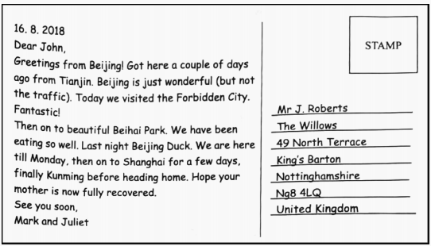

26. This is most probably a(n) _______.

A. poster B. postcard C. E-mail D. advertisement

27. What is Mark and Juliet’s final stop in China?

A. Beijing. B. Tianjin. C. Kunming. D. Shanghai.

28. In Beijing, Mark and Juliet are happy with everything except _______.

A. food B. the Forbidden City

C. Beihai Park D. the traffic

29. Which of the following is true according to the text?

A. John’s mother was ill.

B. Mark and Juliet are going to Chengdu.

C. John lives in America.

D. Mark and Juliet arrived in Beijing in winter.

【答案】BCDA

【导语】

26. B细节理解题。根据右上角的“stamp”， 可知这是信件或明信片。故选B。

27.C 细节理解题。根据正文第二段倒数第二句“.. finally Kunming before heading home”可知最后- -站是昆明。故选C。

28. D细节理解题。 根据正文第一段第三句“Beijing is just wonderful ( but not the traffic)”可知北京除了交通都很棒。故选D。

29. A推理判断题。 根据文中“Hope your mother is now fully recovered”可知John的母亲生病了。故选A。其他三项都可以在文中找到依据。

B

Dear editor,

I am a businessman who has been reading *Modern China* since 2015. Due to my work. I have travelled to many cities in China including Beijing, Shanghai, Xi’an. Guangzhou. and Shenzhen. My favorite one is Shanghai. which is the New York City of the East. I love the historic city of Xi’an too, which I have visited twice. Guangzhou is the manufacturing center and I am attracted by the delicious foods in this big city. Shenzhen. another city in southern China, feels similar to Los Angeles in California. For me, China is not that far apart as 1 read Chinese books and know many well-known Chinese people, for example, Chinese President Xi Jinping，the science fiction（科幻小说）writer Liu Cixin，and superstar CoCo Lee.

*Modern China* is a window for me to learn more about China. Your stories about Chinese culture, people’s life, current events, business, economics, history and politics are all interesting and attractive. All in all, *Modern China* is a high-quality magazine, but I think *Modern China* should also touch upon some issues or problems facing Chinese society. For example, environmental and economic problems can also be discussed so that foreigners can know what the real challenges are and what have been done or will be done to make a change. In this way, your magazine will provide more useful information and attract more readers.

Wesley Wilson

U. S. A.

30. What do we know about Wilson from the text?

A. He is an English teacher

B. He comes from Canada.

C. He is a reader of *Modern China*.

D. He loves the Chinese countryside.

31. Which city is like Los Angeles according to Wilson?

A. Shenzhen. B. Shanghai.

C. Xi’an D. Guangzhou

32. Wilson mentions Liu Gixin in order to show that he _______.

A. gets to know China through his books

B. has a close personal relationship with him

C. admires China’s progress in science fiction

D. is familiar with what is happening in China

33. Why did Wilson write this letter?

A. To show his disappointment with the editor.

B. To share his travelling experiences in China.

C. To ask for more information about *Modern China.*

D. To express his praise and suggestion for the magazine.

【答案】CADD

【导语】

30.C推理判断题。根据短文第一句“I am a businessman who has been reading *Modern China* since 2015.”可知Wilson是Modern China的老读者了。故选C。

31.A细节理解题。 根据正文第一段第四行“Shenzhen. another city in southern China, feels similar to Los Angeles in California. ”可知，Wilson感觉深圳和洛杉矶差不多。故选A。

32. D推理判断题。 根据正文第一段最后一句“For me, China is not that far apart as I read Chinese books and know many well-known Chinese people, for example, Chinese President Xi Jinping, the fiction writer Liu Cixin, and superstar CoCo Lee. (对我来说，中国并没有那么遥远，因为我读中文书,认识很多著名的中国人，比如中国国家主席习近平、小说家刘慈欣、超级明星李玟)”可知此处是为了显示Wilson知道很多中国的事，对中国很熟悉。故选D。

33. D细节理解题。根据文中第二段“All in all, Modern China is a high-quality magazine，but I think Modern China should also touch upon some issues or problems facing Chinese society. ”可知Wilson肯定这是本高质量的杂志,但是又提出了意见,希望杂志可以多涉及一些中国的社会热点问题。故选D。

C

Using a smartphone at mealtimes is making us fat, say scientists. Researchers have found that men and women took 15 percent more calories（卡路里）when looking at their phones while eating. They also ate more fatty food.

The study suggests that looking at a phone screen may distract（分散注意）people from how much food they are actually eating. “It may prevent the brain from correctly understanding the amount of food taken, ” said researchers who watched the volunteers eating alone. Sixty-two volunteers, men and women, aged 18 to 28, joined the study. They were invited to have different types of food—from healthy ones to soft drinks and chocolate—until they were satisfied. Only three of the volunteers were recorded eating with no distraction of a smartphone.

The volunteers ate 535 calories without the distraction of a smartphone but 616 when using a mobile. When using their mobiles, the volunteers also took 10 percent more fatty foods. “Smartphone use during a meal increased calorie and fat intake, ” said Marcio Gilberto Zangeronimoa, a lead author of the study—carried out at the Federal University of Lavras in Brazil and University Medical Center Utrecht in the Netherlands.

He added, “Smartphones have become the main distractor during meals, even early in childhood. It’s making us fat. ”

34. Volunteers using a smartphone took ______ more calories.

A. 10% B. 15% C. 18% D. 20%

35. What does the underlined word “They” in paragraph 2 refer to?

A. Researchers. B. Volunteers.

C. Smartphones. D. Drinks.

36. Volunteers with the distraction of smartphones ate ______than those without it.

A. less calories and less fatty foods

B. less calories but more fatty foods

C. more calories and more fatty foods

D. more calories but less fatty foods

37. Which is the best title for the text?

A. No More Fatty Foods

B. Too Many Calories Do Harm

C. Smartphones Make Us Fat

D. Smartphones Hurt Our Brain

【答案】BBCC

【导语】

[语篇解读]本篇阅读为一 篇说明文，讲述了吃饭时玩手机会让人容易长胖的事情。来自巴西与荷兰的科学家对62名18至28名的志愿者进行了研究，吃饭时耍手机会分散注意力，导致不知不觉食物热量会增加。

34. 细节理解题。 根据第一段第二句...15 percent percent more calories.."可 知答案。故选B

35. 词义猜测题。根据“Sixty-two volunteers, men and women..."可知答案。故选B

36. 细节理解题。 根据短文内容可知，用智能手机分散注意力的志愿者比那些不用智能手

机的志愿者肯定要多吃进热量与油腻的食物。故选C.

37. 主旨大意题。通篇文章都在验证“吃饭玩手机容易致胖”。故选C.

D

Most college graduates wanted to find jobs in large cities. Bu Rui returned to her hometown， a small village in Changchun， to sell her homemade bean curd（豆腐），shortly after she graduated from Changchun University in 2009.

Bu Rui was the first woman in her big family to go to college. All her family were proud of her while she studied in the university. However, when she told them she would return home to make bean curd, to inherit（继承）the family business, most of them turned a cold shoulder to her. But Bu remembered her dream and followed her heart. She decided to use traditional methods to produce bean curd, in an effort to inherit the traditional cultural heritage（遗产）and promote the development of the traditional craft.

After she returned home in 2009, Bu turned her house into a plant. She and her family members made bean curd at night. Every day Bu got up at 3 a. m. , and then carried heavy loads of bean curd to the market to sell the product. During the first month of her business, Bu lost 10 kilograms of body weight. However, because of Bu and her family’s continuous efforts to improve the quality of the bean curd, her business grew rapidly.

Bu’s efforts to develop her business have paid off, as the small plant has become a medium-sized food company. The company’s bean products have sold well in many large supermarkets in Changchun. Her company is the only one in Changchun, whose handmade bean products have been given the National QS(quality standard) Certification.

38. When did Bu Start her business?

A. After her college graduation.

B. While studying in university.

C. As soon as she quit her job.

D. After her parents retired.

39. How did Bu’s family feel about her decision to return home at first?

A. Happy. B. Unsupportive.

C. Confused. D. Hopeful.

40. Bu lost a lot of weight because she _______ .

A. Didn’t get help B. worried too much

C. worked too hard D. ate less than usual

41. Which is the best title for the text?

A. College Graduate and Her Bean Curd Business

B. New Life to Traditional Bean Curd Craft

C. Saving Traditional Cultural Heritage

D. College Students Back to Villages

【答案】ABCA

【导语】

38.细节理解。Bu什么时候开始做生意?根据题目中第一段最后一句，可知为大学毕业之后,所以选A.

39.细节理解。最初她的家人对她回家的决定有什么看法?根据题目中第二段第二行“However,when..most of them turned a cold shoulder to her”可知选择B不支持更合适,故选B.

40.细节理解。Bu为什么体重大幅下降?由题目中第三段可知她和家人晚上做豆腐,凌晨三点起床,扛着沉重的豆腐去市场卖,这说明了是因为工作辛苦导致体重下降，选择C

41.主旨大意。哪个是文章的最佳标题? A大学毕业生和他的豆腐生意合适，文中Bu具有高学历,但仍回家做豆腐。B继承传统豆腐的新生活, C保护传统文化遗产, D大学生返回农村均不合适。故选A

E

On the great plain area in Shandong province, you can find millions of “shiny” houses. What are those? They are greenhouses（塑料大棚）.

In the greenhouse, you can grow all kinds of different vegetables and fruits any time of the year and several times per year. That means you can get several times more vegetable and fruit production compared to normal field.

Therefore greenhouses can significantly improve agriculture output in a limited space, which sounds perfect to the Chinese.

More than that, greenhouses work well with terrible climate. There is a massive amount of greenhouses on the Tibetan plateau（青藏高原）too. As a result, the vegetable price in Tibet has reduced by 90% over the past 10 years. People don’t have to import vegetables from nearby provinces anymore.

According to the Food and Agricuture Organizntion of the United Nations, the vegetable and fruit production and consumption（消费） of China is around 700 million tons. That is 40%of the world consumption. That’s also 3. 8 times of India’s consumption, even though China has less farmland than India.

Thanks to greenhouses, Chinese people can enjoy cheaper and a bigger variety of vegetables and fruits than any other country in the world all year round.

42. Which of the following is true if you grow tomatoes in a greenhouse?

A. You can grow them several times a year.

B. The tomatoes will have better quality.

C. You can sell them at a higher price.

D. The harvest will be less than usual.

43. How did Tibetans get most of their vegetables and fruits 10 years ago?

A. They grew them in greenhouses.

B. They grew them in normal fields.

C. They got them from other countries.

D. They got them from other provinces.

44. The vegetable and fruit consumption of India is around ______ million tons.

A. 40 B. 180 C. 280 D. 700

45. What is the purpose of the text?

A. To introduce a new greenhouse technology.

B. To prove that we live a better life than Indians.

C. To discuss the agricultural development in China.

D. To show how useful greenhouse technology is in China.

【答案】ADBD

【导语】

42.细节理解题。 根据文章第二段中的“That means you can get several times more vegetable and fruit production compared to normal field” 可知，温室大棚里的蔬菜水果可以在一年内收获多次，可以多收几倍的产量。故选A。

43.D 细节理解题。根据文章第四段最后一句“People don't have to import vegetables from nearby provinces anymore”可知，西藏人10年前从别的省购买蔬菜水果。故选D。

44.B推理判断题。 根据文章第五段可知中国每年消费约700 million吨蔬菜水果，是印度的3.8倍，可算出印度约消耗184 million吨。故选B。

45.D 主旨大意题。根据文章最后一段可知，温室大棚给中国人民带来了很大的便利，是非常有用的。故选D。

第Ⅱ卷（共三节 满分30分）

注意事项：

1. 必须使用0.5毫米黑色墨迹签字笔在答题卡上题目所指示的答题区域内作答。答在试题卷、草稿上无效。

2. 第Ⅱ卷共三节，满分30分。

第一节 补全对话（共5小题，每小题1分，满分5分）

阅读下列对话，从所给选项中，选出能够完成对话的最佳选项，并在答题卡上将该项涂黑。选项中有两个多余选项。

Clerk: Can I help you?

Jennifer: Yes. 46

Clerk: I’m sorry, Miss. Not now, you’re not.

Jennifer: 47

Clerk: You’re too late. 48

Jennifer: Oh, no. What am I going to do?

Clerk: Let me see. 49

Jennifer: But my friend is going to meet me at 1:00.

Clerk: Well, your friend is going to have to wait.

Jennifer: 50 I’m never going to be late again.

|  |
| --- |
| A. That’s too bad!  B. What do you mean? C. I’m going to Beijing.  D. The next flight is at 4:30.  E. The train has just arrived.  F. The plane is talking off right now.  G. Go straight and Gate 6 is on your left. |

【答案】CBFDA

【导语】

46.上一句中问道需要帮忙吗? ”，由此得知二者的关系为服务与被服务的关系，那么答者应该具体说明自己想询问的问题，再根据所有的选项判断是有关乘火车或飞机迟到的内容，则此处应该向柜台工作人员询问有关

出发时间的，则答案为C

47.根据上一句中的"Not now, you're not."一句意义不明的话和空后的“你来的太迟了”这句意义明显的话可以推断该空所要表达的是让工作人员解释清楚所表达的意思，则答案为B

48.由下一句中的"Oh, no."和上一-句中的"too late"可以推断本句是在表达已经错过了想要乘坐的交通工具，浏览选项可知表达这个意思的有E、F两选项，E项表达火车刚开走，F项表达飞机正在起飞，再由下面乘客所问

”那我接下来该怎么办”，工作人员说“让我来看看”,乘客又说"但我和我的朋友要在一-点见面” ，由此判断工作人员所看到的下一趟是超过一点的， 由选项可知，只有D项表达了这个意思，D项中所说的交通工具为飞机，则乘客原本选用的交通工具也应该是飞机，则答案为F

49.工作人员说“让我来看看”，乘客又说“但我和我的朋友要在一点见面”，由此判断工作人员所看到的下一趟是超过一点的， 由选项可知，只有D项表达了这个意思，则答案为D

50.根据语境，工作人员说“那你的朋友只能等着了”，乘客说“我再也不会迟到了”，由此可知乘客表达了一种难过但又没办法的心情，则答案为A

第二节 翻译（共5小题；每小题2分，满分10分）

**Part A** 请将下面的英语句子翻译成汉语，并将答数写在答题卡相应的横线上。

51. May you succeed!

52. Apples are on sale on Wednesday.

53. It’s never too late to learn.

【答案】

51.愿你成功！

52.苹果星期三打折。

53.学习永远不会太迟。

**Part B** 请根据所给中文提示，将下列译成英语的句子补充完整，并把答案写在答题卡相应的横线上。

54. 我想和负责人谈一谈。

I want to speak to the person __________ __________ .

【答案】 in charge

【解析】in charge 主管;全面负责 ; 统领

55. 再等一分钟，我就能完成工作。

One more minute, __________ I’ll get the work __________ .

【答案】and; finished/completed

【解析】考查句型与固定搭配句意:再等我一分钟我就能完成任务。 考查祈使句，+ and/or +陈述句，后面的陈述句用一般将来时，所以第一空填and;第二空考查固定搭配get sth done完成，所以填finished/completed,故填and;finished/completed

第三节 书面表达（满分15分）

假设你是李华。你班本周日去东湖公园植树，请给外教Sara发一封邮件，邀请她参加。内容包括：

1. 具体安排；2. 注意事项；3. 盼回复。

注意：1. 词数80左右（开头语及结尾已为你写好，不计入总词数）；

2. 不得透露任何个人信息，否则不予给分。

Dear Sara,

How is everything going? I’m writing to

_______________________________________________________________________________

Yours,

Li Hua

【答案】

Dear Sara,

How is everything going? I'm writing to invite you to join our weekend activity.

We are going to plant trees in Donghu Park this Sunday. Over 30 members will take part in this activity including students and social volunteers. We are going to meet at the school gate at 8: 00 a. m. It is very important to dress sports clothes and shoes instead of skirt and high-heel shoes. Sun helmet is necessary as well. We will take a photo together in the end.

Looking forward to your reply soon !

Yours,

Li Hua

【详解】

【总体分析】本篇书面表达要求考生写一封邀请信。

题材：邀请信

时态：一般将来时

人称：第一人称

提示：邀请信通常包含展览，活动，节日，聚餐，邀请某人担任某个比赛的评委火灾讲座上发言等各种邀请信件。要求叙事一定要清楚，明白，要写清楚以下三个方面的内容：

【包含内容】

开篇： 点明写信的目的——向某人发出邀请。

正文： 邀请对方的原因及邀请的具体内容，如时间和地点等。

结尾：期待对方接受邀请，并希望尽快得到回复。

【高分句型】

1.Over 30 members will take part in this activity including students and social volunteers.（本次活动将有30余名会员参加，其中包括学生和社会志愿者。）（运用including,主要用作为动词，用作动词译为“（使）成为……的一部分；允许（某人）加入活动（或同享特权）（include 的现在分词）prep. 包括……在内”。

2.It is very important to dress sports clothes and shoes instead of skirt and high-heel shoes. (穿着运动服和运动鞋而不是裙子和高跟鞋是非常重要的。)( instead of prep.代替；作为…的替换  
in the place of sb/sth

We just had soup instead of a full meal.我们没有吃全餐，只喝了汤。)